Lewis Kirigami Face Shield

Technical Research Document

https://lh3.googleusercontent.com/7pEilbtiBoxe2q33jSnEJnFHYgbvXnqpCQI6BvFiPNUI0f3d6iyKtgAJ9hOOeK4LTNlWXk0E-pO0XCEnXMm62dik0YwnpY6wWuNlk8wLdKeaxnlleDoyN7mkj_8f8_jFBNKe27Q

Objectives:

In response to the Covid-19 pandemic, the MGB Center for Covid-19 Innovation originated as a collaborative network of four distinct pillars: Devices, Diagnostics, Data Analytics, and Therapeutics. The Lewis Kirigami face shield design was a result of collaboration and interaction between members of the Face Shield working group organized under the Devices Pillar at the MGB Center for Covid-19 Innovation. This group consists of >400 volunteers, designers, clinicians and manufacturers sharing innovative ideas. Various parts of the Lewis Kirigami design were selected and optimized based on various design options suggested by the community. A few contributors include Columbia University, Lacerta, the Lewis Lab at Harvard University, and the MGB Center for Covid Innovation. The design was further iterated and optimized based on user evaluation results. Design reviews were held in a series of Zoom meetings to evaluate and finalize designs.

Disclaimer:

**Awaiting formal disclaimer**

*[The information contained on this website is provided by the MGB Center for COVID Innovation (MGB-CCI) and is for general information purposes only and is not intended to be used as a reference for funding or grant proposals. In no case does the inclusion or exclusion of products or information contained on this website represent an endorsement nor should it be interpreted as judgement on validity or legitimacy of tests. While we attempt to keep the information current and correct, MGB-CCI cannot and does not guarantee the accuracy, reliability, suitability or completeness of the information and products contained on the website for any purpose. Any reliance placed on such information is therefore solely at your own risk.*

*In no case will MGB-CCI be liable for any loss or damage including without limitation, indirect or consequential loss or damage, or any loss or damage whatsoever arising from loss of data or profits arising out of or in connection with the use of this document.]*

What is a Face Shield?

Face Shields are used to protect user's eyes, face, and other PPE from bodily fluids, liquid splashes, or potentially infectious materials. They are intended for use in conjunction with other appropriate PPE. The use of a face shield does not guarantee complete protection from disease transmission.



Research Document Only 6/24/2020 V1.1

1

Design Specifications:

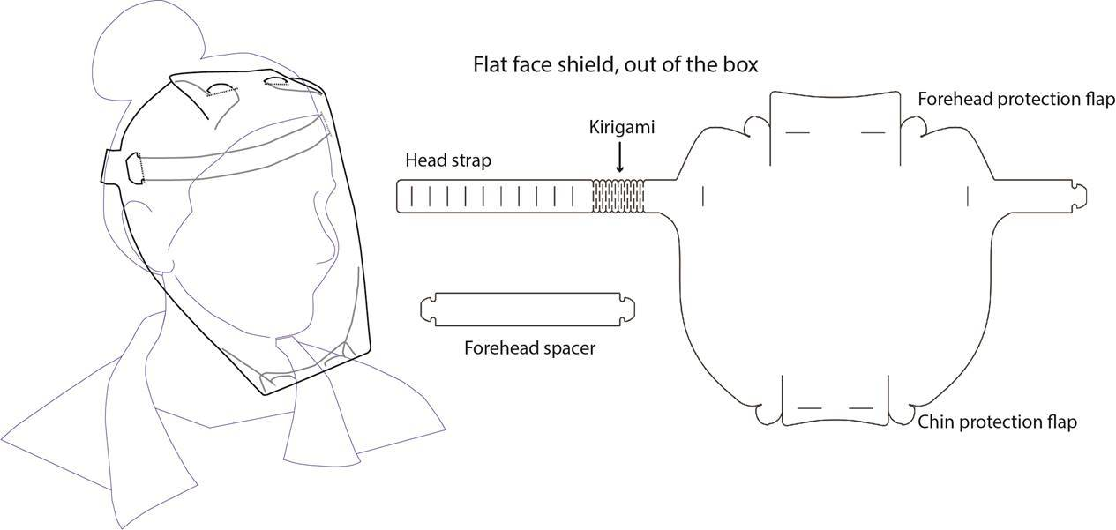

Low-cost and disposable single-material (all-plastic) design. Can be manufactured at scale by die-cutting manufacturing methods.

* Can be shipped in large quantities in a flat state
* Features chin and forehead protection
* Can be cleaned with alcohol-based antiseptic wipes for extended use or re-use
* Can be used with general PPE (surgical mask, N95 respirator, hair net)
* Can be used with stethoscope and other general clinical tools
* Requires assembly by the end user
* Features an adjustable head strap to accommodate all head morphology
* Features a kirigami pattern to provide elasticity to the head strap

Methods:

The Critical Design Inputs determined by the MGB Center for COVID Innovation for face shield equivalents are as follows:

* Must protect eyes, nose and mouth from splashes, sprays, spatter, and body fluids
* Must protect from splash to drip down from forehead and splash from below the chin
* Visor must be optically clear and not impede frontal vision
* Visor must be resistant to fog
* Must not hinder movement
* Must stay in place
* Must be compatible with off the shelf disposable surgical mask or respirator use
* Must be compatible with stethoscope use
* Must be comfortable to use for a full day shift (up to 12 hours)



Research Document Only 6/24/2020 V1.1

2



Research Document Only 6/24/2020 V1.1

3

Manufacturing Instructions:

Bill of Materials

* + Anti-fog coated PET transparent film
    1. Minimum roll width of 20”
    2. Thickness: 0.010” - 0.015”

Research Document Only 5/13/2020 V1.0

Manufacturing Process

* Die-cutting of the face shield and forehead spacer
* Flat packaging for shipment

Repurposing

* Alternative film materials such as PETG, acrylic, PU etc. can be considered in case of a PET shortage. However, the center did not evaluate the resistance of these alternative materials to cleaning agents.
* In case anti-fog coating is not available, films without a coating can be used. However, these may result in worse fogging performance.

Preparatory Steps

* No preparatory steps are required.  The face shield is ready to assemble out of the box.
* Assembly Instructions:

[Note: An opaque shield is used to aid visualization. The actual face shield is transparent.]

Appropriate Use Criteria/Instructions

* Helps protect user's eyes, face, and other face-protecting PPE from bodily fluids, liquid splashes, or potentially infectious materials.
* Intended to be used as a general-purpose disposable face shield.
* Can be reused by the same user if the cleaning procedure is followed and there is no visible damage to parts.
* Only for use in conjunction with other appropriate PPE. The use of this device does not guarantee complete protection from disease transmission.

Cleaning Procedures

1. The face shield should be cleaned only after removal (doff) when visibly soiled
2. Perform hand hygiene
3. Don a clean pair of gloves
4. Carefully wipe the outside of the eye protection using compatible cleaning agents
   * 1. If any visible material degradation occurs during cleaning, dispose of the face shield
5. Allow to air dry
6. Remove gloves and perform hand hygiene

Testing

Physical testing results

Cleaning Agent Compatibility Test: The PET material was analyzed using prior research to understand its chemical resistance. Based on literature review and qualitative in-lab testing with appropriate chemicals, we have determined that: 1) the shield will not be negatively affected by isopropyl or ethyl alcohol, and 2) the shield integrity will not be negatively affected by bleach-based solutions. However, contact with these chemicals tends to leave residue that affects the transparency of the shield.

User Validation testing

* User validation tests were performed with Lewis Kirigami face shield samples manufactured at Prof. Jennifer A. Lewis’ lab at the Wyss Institute. All components met all intended material, design and dimensional specifications for this design.
* Samples were given to the participants in a fully assembled state.
* Responses to features related to comfort, coverage, ease of use, durability and other design input requirements were collected. In addition, the participants were also asked their job title and gender.

Research Document Only 6/24/2020 V1.1

4

* Participants were asked to rate features on a 1-5 scale from insufficient (1) to sufficient (3) to excellent (5). A passing grade was established as 3.0, and all features were expected to get an average score above this.
* Participants in this study were residents and employees of the Trauma Surgery Department of Massachusetts General Hospital.
* In a separate user validation test, participants were asked to rate the same set of features for the standard face shield currently used at the MGH (Alpha Pro Tech Critical Cover® Coverall®). Participants in this study were residents and employees of the Emergency Department of Massachusetts General Hospital.
* A summary of results of both user validation tests are given below:

|  |  |  |
| --- | --- | --- |
| Specification | Lewis Kirigami  Face Shield  (N=14, average) | MGH Standard  Face Shield  (N=13, average) |
| Comfort | 4.0 | 3.6 |
| Fit | 4.1 | 3.6 |
| Visibility | 3.9 | 3.7 |
| Face Coverage /Protection | 4.4 | NA |
| Fogging | 4.3 | 3.5 |
| Up/Down Range of Motion | 3.6 | 3.7 |
| Left/Right Range of Motion | 3.6 | 3.7 |
| Ability to Stay in Place During Quick Motions | 3.7 | 3.6 |
| Don and Doff Procedure | 3.1 | 3.8 |
| Compatibility with stethoscope | 3.4 | 3.8 |
| Compatibility with general PPE | 4.0 | 3.7 |
| Overall Impression | 3.6 | 3.6 |

Packaging:

Storage

* Shields are stored in their shipped package as flat packed unassembled face shields.

Distribution

* Shields will be distributed to hospitals directly by the manufacturer.



Research Document Only 6/24/2020 V1.1

5

Other:

Cleaning Agent Compatibility

* + Alcohol-based cleaning agents (e.g. alcohol wipes) with 70% isopropyl alcohol and/or 70% ethanol content can be used
  + Bleach-based cleaning agents (e.g. 10% bleach, Virex) can be used, however, these may leave residue
  + Cleaning agents may remove anti-fog coating and the fogging properties of the shield can degrade over extended use or re-use

Warnings

* This product has not been FDA cleared or approved
* This product has been authorized by FDA under an EUA for use by healthcare providers as personal protective equipment

Research Document Only 6/24/2020 V1.0

6

* This Product is not intended for:
  + Surgical use
  + Uses where significant amounts of exposure to hazardous fluid is expected
  + Situations where level 3 or 4 protection is required
  + Situations with a possibility of exposure to high heat or flammable gas

